**YOLO** is an algorithm that uses neural networks to provide real-time object detection. This algorithm is popular because of its speed and accuracy. It has been used in various applications to detect traffic signals, people, parking meters, and animals.

YOLO is an abbreviation for the term ‘You Only Look Once’. This is an algorithm that detects and recognizes various objects in a picture (in real-time). Object detection in YOLO is done as a regression problem and provides the class probabilities of the detected images.

YOLO algorithm employs convolutional neural networks (CNN) to detect objects in real-time. As the name suggests, the algorithm requires only a single forward propagation through a neural network to detect objects.

This means that prediction in the entire image is done in a single algorithm run. The CNN is used to predict various class probabilities and bounding boxes simultaneously.

Why the YOLO algorithm is important

YOLO algorithm is important because of the following reasons:

* **Speed:** This algorithm improves the speed of detection because it can predict objects in real-time.
* **High accuracy:** YOLO is a predictive technique that provides accurate results with minimal background errors.
* **Learning capabilities:** The algorithm has excellent learning capabilities that enable it to learn the representations of objects and apply them in object detection.

How the YOLO algorithm works

YOLO algorithm works using the following three techniques:

* Residual blocks
* Bounding box regression
* Intersection Over Union (IOU)

Residual blocks

First, the image is divided into various grids. Each grid has a dimension of S x S. The following image shows how an input image is divided into grids.

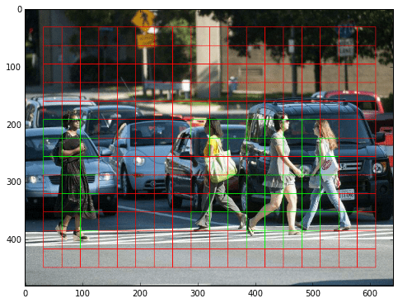

Applications of YOLO

YOLO algorithm can be applied in the following fields:

* **Autonomous driving:** YOLO algorithm can be used in autonomous cars to detect objects around cars such as vehicles, people, and parking signals. Object detection in autonomous cars is done to avoid collision since no human driver is controlling the car.
* **Wildlife:** This algorithm is used to detect various types of animals in forests. This type of detection is used by wildlife rangers and journalists to identify animals in videos (both recorded and real-time) and images. Some of the animals that can be detected include giraffes, elephants, and bears.
* **Security:** YOLO can also be used in security systems to enforce security in an area. Let’s assume that people have been restricted from passing through a certain area for security reasons. If someone passes through the restricted area, the YOLO algorithm will detect him/her, which will require the security personnel to take further action.